Assignment 5: ADF Pipeline 3

**1. Create a pipeline name 'Without_Foreach_Example' to copy the Customer & Customer address table data into ADLS without using foreach activity.**

## 2. Create a pipeline name 'Foreach_Example' to copy the Customer & Customer address table data into ADLS using the one copy activity.

**3. Create a pipeline name 'Foreach_Example_2' which solves the following business use case.**

**Customer data is very important for our business. Hence whenever we have more than 100 records in the customer table, we copy the customer data to another table customer_copy within the sql db.**

**However, whenever we do this copy, we first truncate the table 'customer_copy' and then copy the data from 'customer' table.**

First, I created the Customer_Copy table in the SQL server DB on [SalesLT] schema using the below query. Please note only the table structure is created without copying data from customer table.

IF (NOT EXISTS (SELECT 1

FROM INFORMATION_SCHEMA.TABLES

WHERE TABLE_SCHEMA = 'SalesLT'

AND TABLE_NAME = 'Customer_Copy'))

BEGIN

select * into SalesLT.Customer_Copy from [SalesLT].[Customer] where 1=2

END

**4. Business wants to move the data from 3 different tables (Customer, Product, CustomerAddress) to ADLS location in CSV format.**

**However, they want the make a pipeline in such a manner that All these copies happen through an individual pipeline, which is called by one common pipeline.**

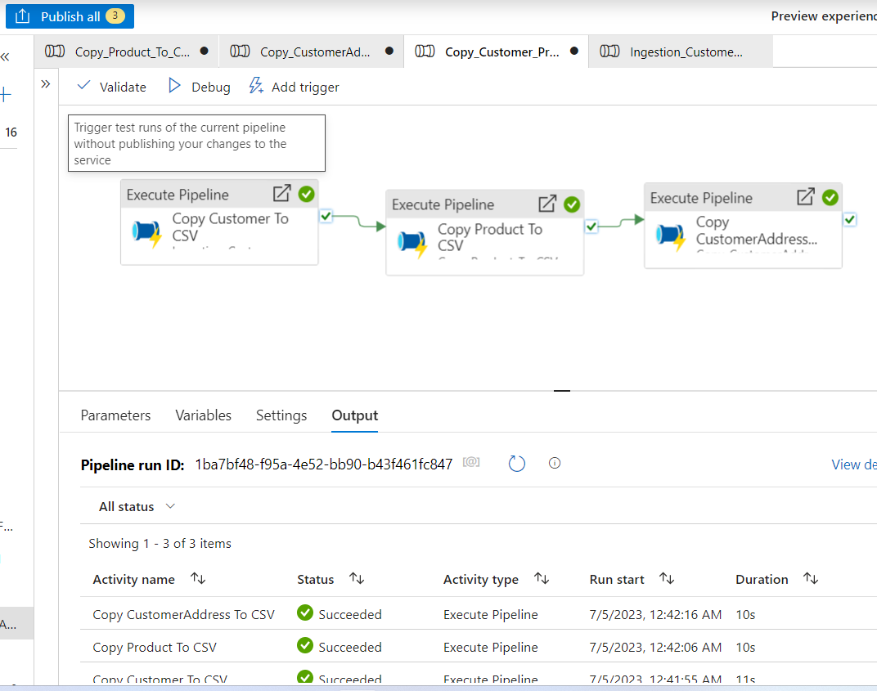

**5. In the above case problem is that every time the pipeline runs it will overwrite the data. Ensure that all the data goes into Folder like (Customer/Year/Month/Day) to avoid any overwriting. Please rewrite the pipeline.**

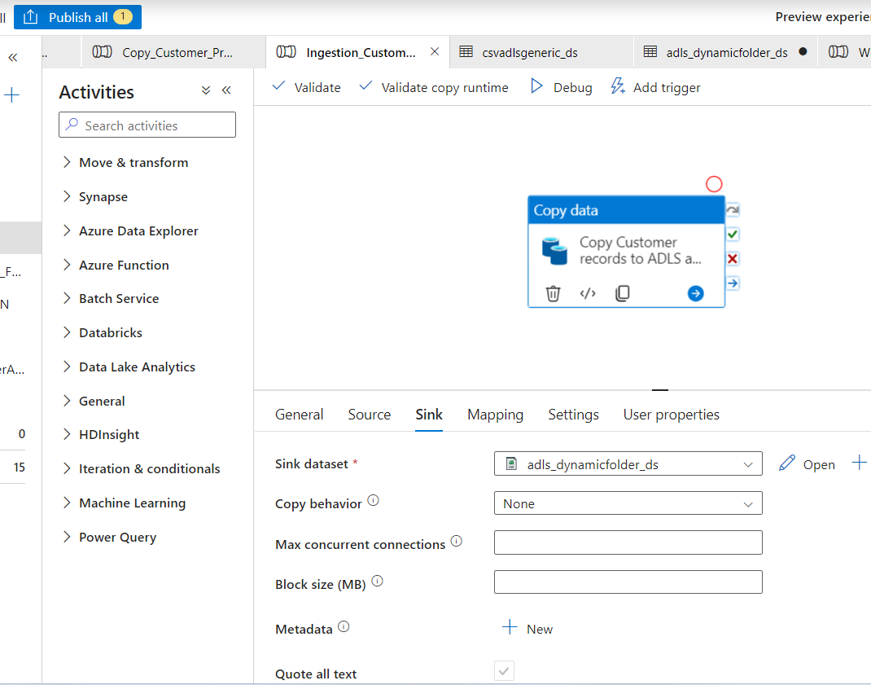

**6. I am attaching a file, load this file into your ADLS location. This file contains a threshold value. Create a pipeline in such a manner that, it will first get the threshold value from this file and then check if the record count in the customer table is more than it or not. If yes then copy the customer data from SQL db to ADLS location in JSON format.**

Threshold value file is not available.